Pizza Sales SQL Queries

1. KPI’S
2. Total Revenue –





1. Average Order value –





1. Total Pizzas Sold –



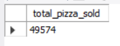

1. Total Orders –

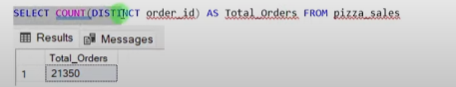

1. Avg. Pizzas Per Order –





1. Daily TREND FOR TOTAL ORDERS

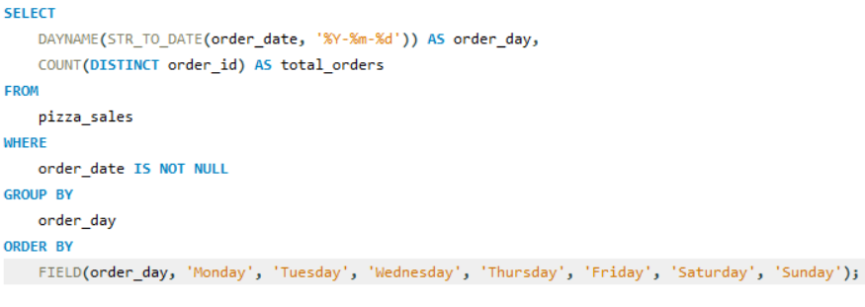

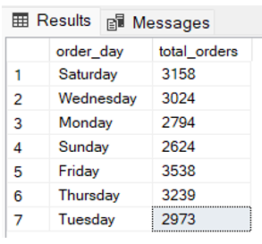

1. Hourly Trends for Orders –

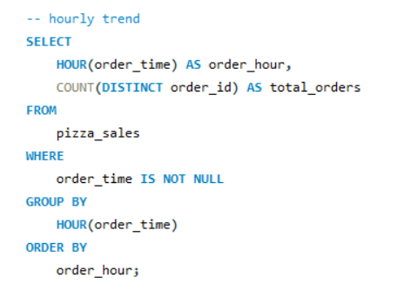

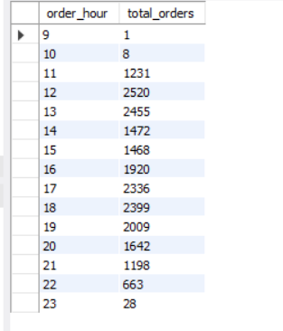

1. Percentage of sales by pizza category –

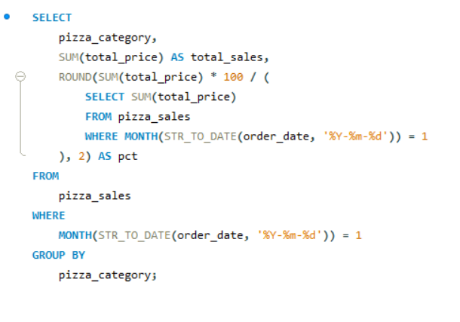

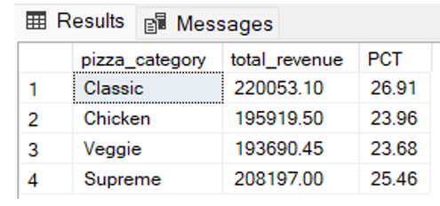

1. Percentage sales by Pizza Size –

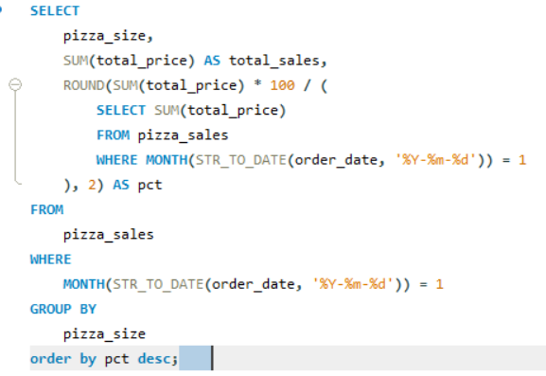

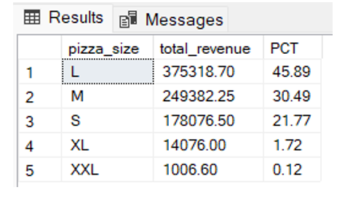

1. Total Pizzas sold by Pizza category –

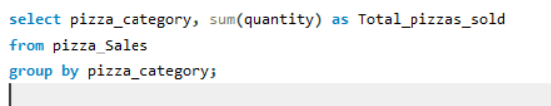

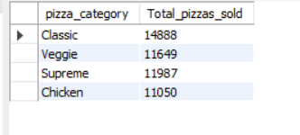

1. Top 5 best sellers by total pizzas sold –

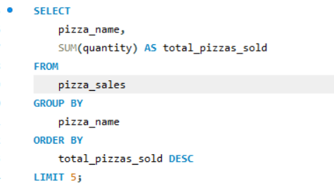

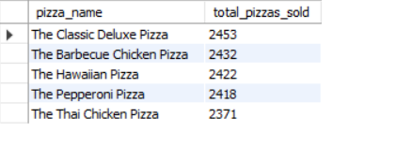

1. Bottom 5 worst sellers by total pizzas -

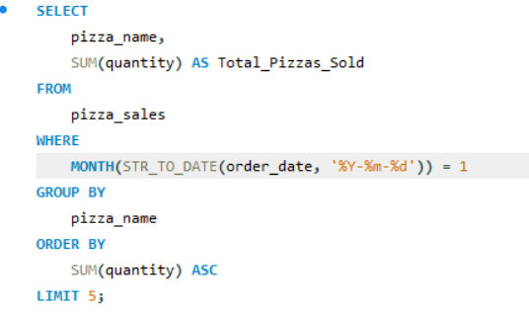

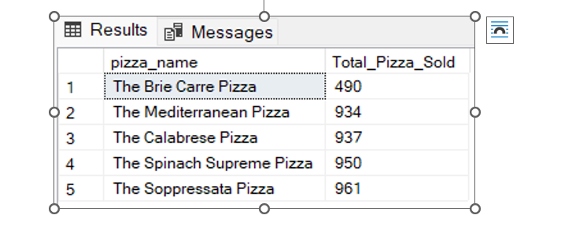

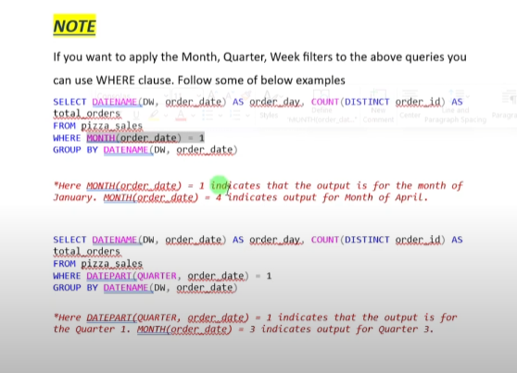

Key note - code will varies MySQL workbench, MS SQL server.